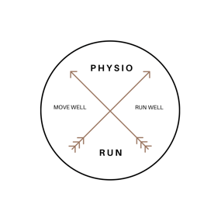
Running : Tracker
- Specific weekly goal:

  - Distance: ______________
  - Frequency: ______________
  - Strength Sessions:
  - Life Events:

- Weekly Schedule:

 | Distance | Purpose of Session | Duration of Session | Average Pace for Session | Notes for the Session | Achieved  (Tick)
Monday
Tuesday
Wednesday
Thursday
Friday
Saturday
Sunday

Ths tracker helps you document your running journey. It also helps to keep you accountable to the goal you have.

Distance – Can be in miles or Kilometres.
Frequency – How many runs you complete a week.
Strength session – how many do you commit to completing this week – can include physio sessions or yoga/Pilates etc
Life event – what else do you have going on at present, be aware this may have an effect on your training.

